AP Human Geography Workshop – KGA – September 17, 2016

HANDOUT INCLUDES:
- Site & Situation
- Common Settlement Patterns
- Settlement Models
- Modern Urban Areas
- Contemporary Influences on Urban Development
- Primate City Activity

Site & Situation
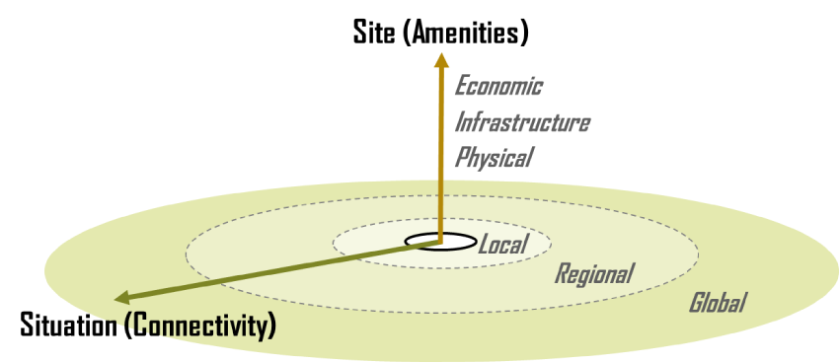
Source: The Geography of Transport Systems. 2016. https://people.hofstra.edu/geotrans/eng/ch1en/conc1en/sitesituation.html

Site – the actual place or spot on Earth’s surface where the settlement was located

Situation – relation to accessibility and resource availability

Site Factors
- water supply
- “away from flood risks”
- defense
- building materials (wood, stone)
- fertile land
- sheltered from winds
- fuel supply (wood)
- south-facing slope
- flat land, easy to build on
- natural harbor

Situation Factors
- route center
- lowest bridge point on river
- port
- minerals for export

Source: Site and Situation. Barcelona Field Studies Centre. 2016. http://geographyfieldwork.com/SiteSituation.htm
Common Settlement Patterns
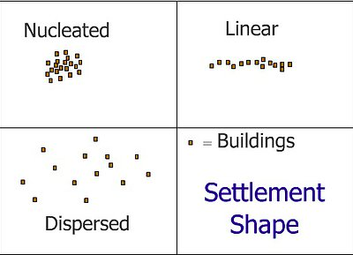
Source: Settlement Diagrams. 3D Geography. 2016 http://www.3dgeography.co.uk/settlement-diagrams

Settlement Models

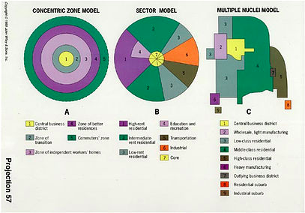
Source: Settlement Diagrams. 3D Geography. http://www.3dgeography.co.uk/settlement-diagrams

The three models:
- developed by sociologists, economists, and geographers
- describe the internal structure of a city
- objective is to explain urban patterns.

Concentric Zone Model

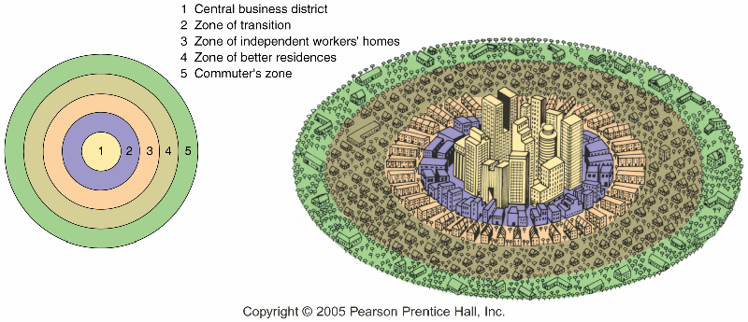
Concentric Zone Model. Science People. 2016
http://sciencepole.com/concentric-zone-model/

Concentric Zone Model – created by E.W. Burgess – 1925 City grows outward in a series of rings.
- Inner circle is the CBD (central business district)
  - where non-residential activities occur
  - offices, retail, banking, government
- Second Ring – transition zone
  - Industry
  - Lower quality housing – usually due to decline of previously nice housing that has been replaced over time by low-income housing
- Third Ring – zone of working-class homes
  - Older houses, not fancy
- Fourth Ring – middle class families
  - Newer more spacious homes
- Fifth Ring – commuter zone
  - Area beyond the city occupied by commuters

Concentric Zone Cities
- based on the city of Chicago – there were no mountains to hinder or change the growth/development patterns
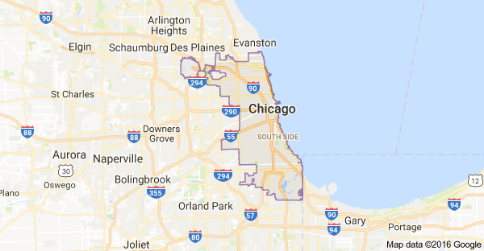
Source: Google Maps.

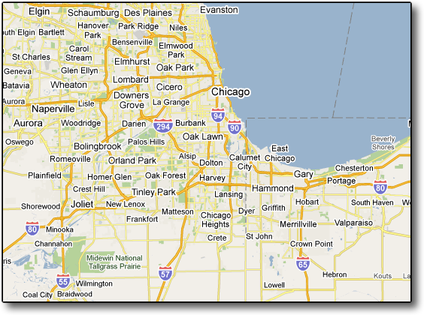

Criticism of Concentric Zone Model:
- Assumes the landscape is flat with no interruptions in the landscape. It does not take into account elevation changes and water bodies: mountains, hills, lakes, and rivers.
- Does not take into account transportation improvements. Towns and cities grow toward divided highway interchanges.
- Assumes transportation is the same throughout the city
- Primarily based on residences
- Commuter villages and “bedroom” communities do not fit the plan

Sector Model (Hoyt Model) – developed by Homer Hoyt in 1939

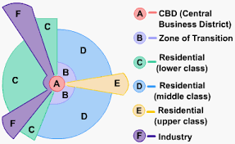

Development of city occurs in a series of sectors.
- Combination of rings and wedges
  - Wedges follow the line of major roadways & railroads
- Environmental factors – certain areas are favored for development
  - Rivers – industry and trade
  - Parks
- Transportation routes – cities grow around transportation routes
  - Rivers
  - Sea ports
  - Railroads
  - Interstate and freeway interchanges
- Other zones:
  - Educational zones
- Hoyt concluded that transportation was most influential to a cities shape
- Hoyt used Chicago as a model
  - Higher income residential areas grew to the north of the city along the lakeshore
  - Industry developed to the south of the city along railroads

Criticisms of the Sector Model:
- Based on 20th century cities and does not take into account change in transportation (cars)

Sector Model City Example: Baltimore, MD
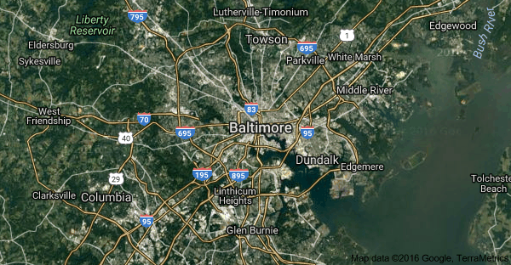
Source: Google Maps

Chicago graphic - Shows changing median incomes over the last 40 years:
http://cdn.citylab.com/media/img/citylab/legacy/2014/04/02/incseggif.gif
Source: City Structure Model. City-Building. 27 Aug 2014. https://citybuildingcrashcourse.wordpress.com/2014/08/27/city-structure-models/

Sector Model city example: London, UK
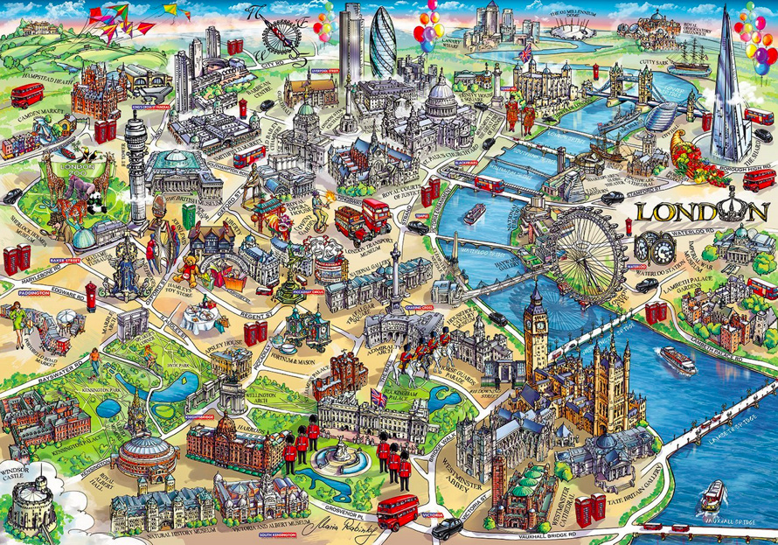
Source: Mapping London. http://mappinglondon.co.uk/

Sector Model city example: Newcastle, UK
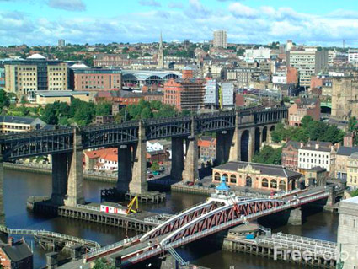
Source: Phone Book of Newcastle Upon Tyne. http://phonebookoftheworld.com/newcastleupontyne/

Multiple Nuclei Model – C.D. Harris & Edward Ullman – 1945
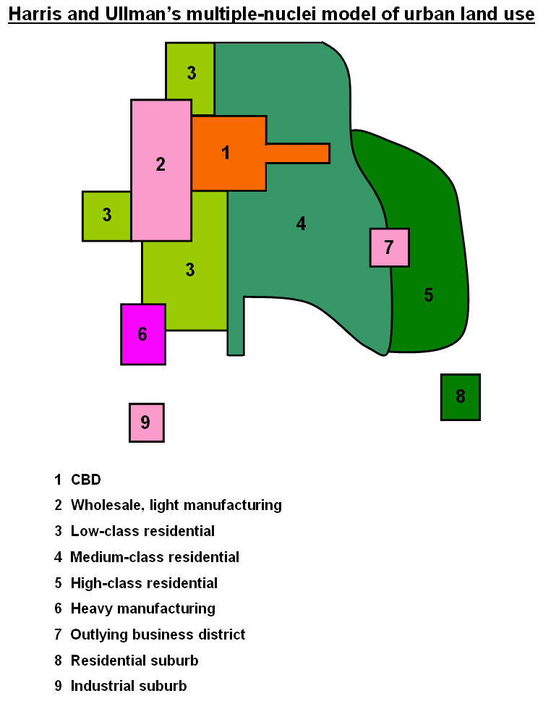
Source: The Internal Structure of Cities. http://cronodon.com/PlanetTech/Cities_Structure.html

- Complex structure with more than one activity center
- Usually a historic city center (CBD)
- New activity centers in the outskirts – smaller CBDs
  - Near higher income residential areas
  - Allows shorter commutes
- Nuclei – growing points – occur due to four factors:
  - Location of CBD
  - Concentrations of working groups
  - Closeness of industry and pollution
  - Rent rates of desirable sites
- Industry in a multiple nuclei model
  - Transport areas – airports, railroads, sea ports, river ports
  - Industry develops near transportation hubs
  - Increase in noise pollution, LULUs (local unwanted land use) and NIMBYs (not in my back yard)
  - Area becomes less desirable for housing = property values go down
  - Houses that were occupied by homeowners become rental property
- Residential areas
  - Develops in areas between transportation hubs, industry, retail areas, and CBDs
  - High-income areas tend to be in areas with more trees
- Multiple nuclei model fits large expanding cities

Criticisms of multiple nuclei model:
- Shows even distribution of residential areas, CBDs, transportation hubs, and retail; but in reality these areas are not evenly distributed.
- Includes heterogeneous zones, rather than overall homogeneity
- Does not take government policy into account = zoning laws
- Model does not fit cities in all regions due to cultural differences such as economic income and government-type.
- Not a simple model, it is more complex.

Source: Multiple nuclei model (Town Planning). S.M. ATik. Jagannath University. Posted 27 Dec 2014. http://www.slideshare.net/atikulsm/multiple-nuclei-model

Multiple Nuclei Model Example: Los Angeles, CA
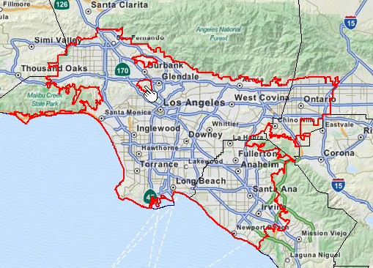
Source: Urban Structure Models. Martin’s AP Human Geography. 2012.
http://www.martinsaphug.com/learn/units/urbanization/urban-structure-models/

Multiple Nuclei City Example: Ottawa
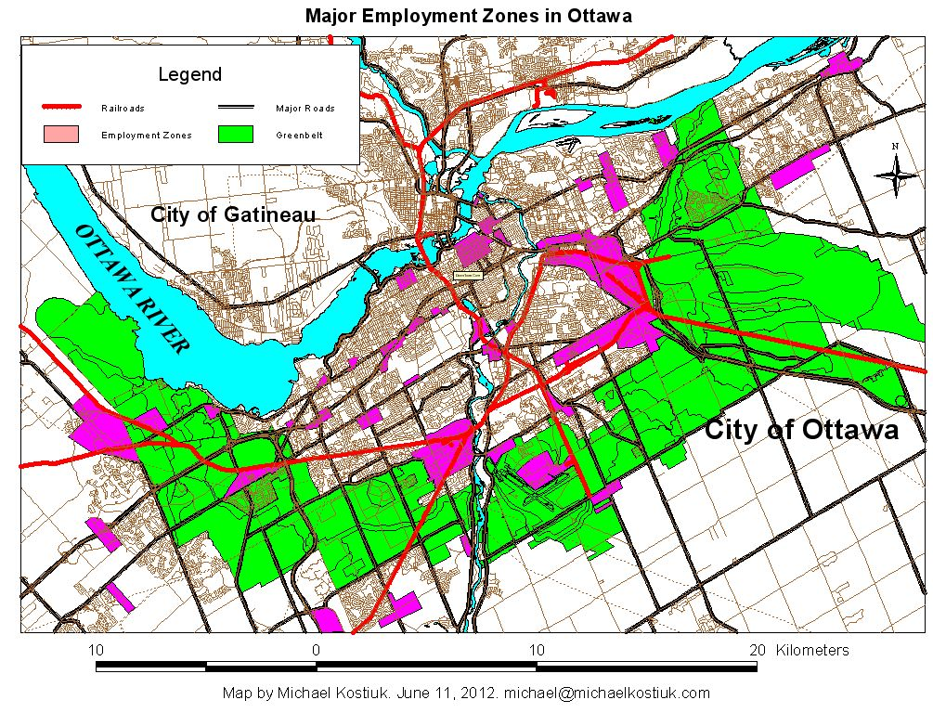
Source: The Greenbelt, Satellite Cities and Transportation in Ottawa. 21 Jul 2014. http://www.michaelkostiuk.com/greenbelt/index.html

Modern Urban Areas
Large modern urban areas are made up of a combination of settlement shapes and include aspects of the three city models.

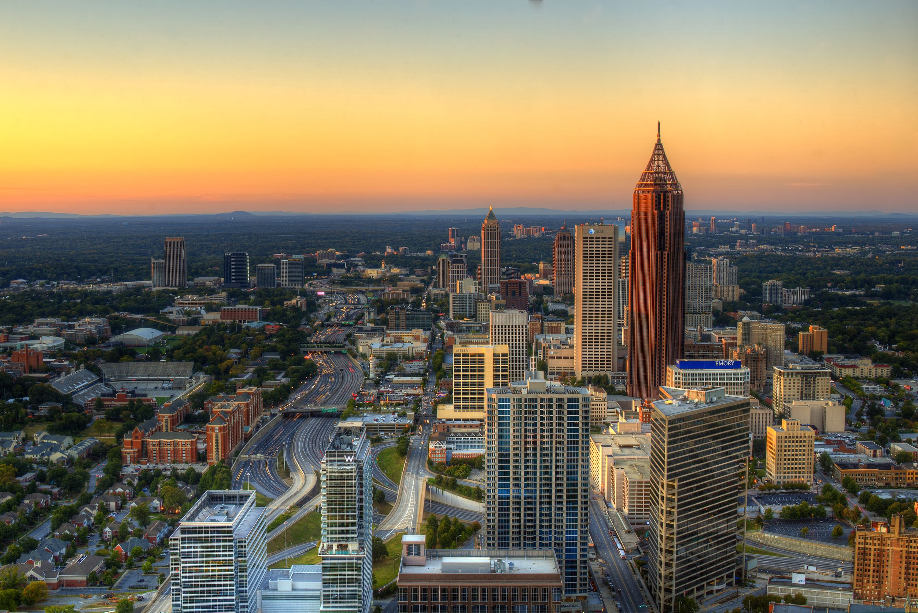
Source: All About Atlanta. 2016. http://www.movoto.com/guide/atlanta-ga/

Contemporary Influences on Urban Development
- Rural-to-urban migration
- Transportation improvements
- Zoning and government regulations
- Urban regeneration and gentrification – change to low-income housing areas
- Specialization of areas for certain types of commodities
- Dominant sector of the economy:
  - Industrial
  - Service
  - Information Technology
- Globalization & interregional linkages

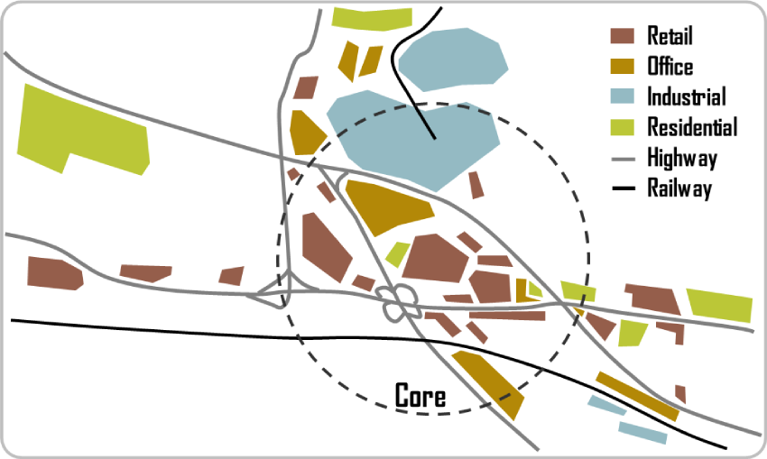
Source: The Geography of Transport Systems. 2016. https://people.hofstra.edu/geotrans/eng/ch6en/conc6en/subhighway.html

Primate City Activity
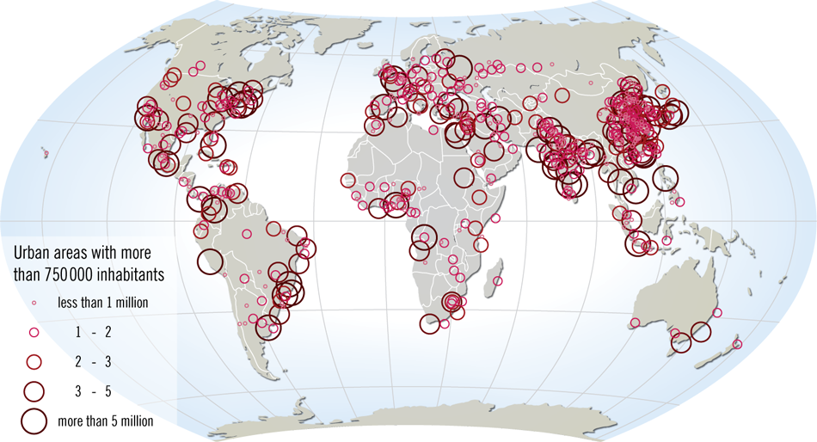
Source of image: Rank Size versus Primate City. APHG Class Wiki. http://lewishistoricalsociety.com/wiki2011/tiki-read_article.php?articleId=106

- Put students in groups of four.
- Provide a list of countries in Middle & South America.
- Ask the students to write down as many cities as they can think of for some of the countries. This is a brainstorm session so they cannot use their phones. (Oftentimes, they can only think of one, even in a group.)
- After a few minutes, ask them to get out their mobile learning devices (phone, iPad, or other electronic device) and pull up the CIA World Factbook.
- For each country they discussed, have them look up the name and population of the largest and second largest city. Write the information down. (At this point, it would be best to ask each group to do a specific country that you would like to use on the exam and for which you already have the data.
  - CIA World Factbook instructions:
    - Go to the CIA World Factbook website: https://www.cia.gov/library/publications/the-world-factbook/
    - Use the dropdown box “Select a country to view”
    - Scroll down and click on the plus (+) button to the right of “People and Society”
    - Scroll down to “Major urban areas – population”
- While the students are working, make a table on the board:
Country | Larges City & Population | Second Largest City & Population
- Allow the students time to locate the necessary information.
- Ask the students to share what they have found and fill in the table.
- Students will begin to comment on how much larger the biggest city is. You may have already noticed this in their group discussions.
- Once you get enough data on the table, you can give them the definition of primate city.
- Ask them what the primate city is in the United States. Have them look up the population of NYC, LA, and Chicago.

Middle & South America Activity Primate City In-class Activity

Look over the list of countries in Middle & South America. List as many cities as you can think of for each country.

Mexico
Nicaragua
Honduras
Cuba
Panama
Costa Rica
Dominican Republic
Haiti
Belize
El Salvador
The Bahamas
Jamaica
Trinidad and Tobago
Dominica
Saint Lucia
Antigua and Barbuda

Barbados
Saint Vincent and the Grenadines
Grenada
Saint Kitts and Nevis
Argentina
Bolivia
Brazil
Chile
Colombia
Ecuador
Guyana
Paraguay
Peru
Suriname
Uruguay
Venezuela

