2015 American Cornhole Organization World Championship Attendees
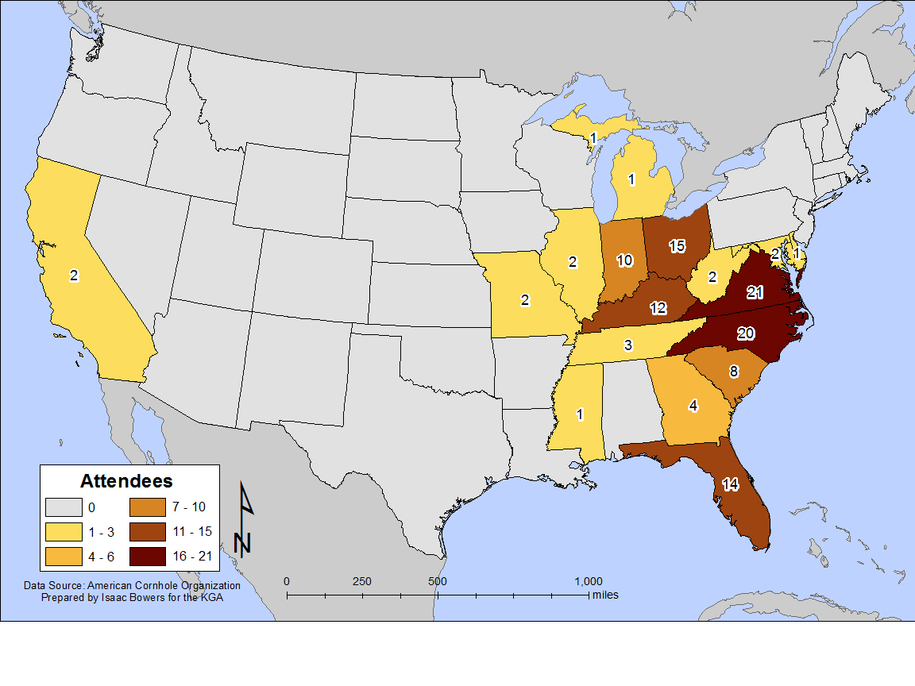

Most people from around the Ohio Valley region are familiar with the game of cornhole, which involves tossing bags filled with corn kernels onto boards several feet away. According to the American Cornhole Organization (ACO), the game likely originated in Germany in the 14th century, and resurfaced in the 1800’s in the mountains of eastern Kentucky. Because of the popularity of the game across the area, the ACO recently selected Owensboro, KY to host its annual World Championship games in July 2017.
Last year, the games were held in Knoxville, TN, and drew people from all across the country. Geographers can use information like the origins of participants to find spatial patterns. The map above shows states of origin for the top 120 participants in last year’s championship games. Can you identify a spatial pattern in the map above? If so, why do you think it exists? What other things might show similar spatial patterns to the one seen above? What economic advantages could Kentucky gain by hosting other events like these?

